

We choose environmentally friendly food
As a Green Key establishment, we make special efforts to preserve the environment. We make food in an environmentally friendly way using organic, seasonal and/or locally produced products.

We want to make it easy for you to care for the environment – also when you eat – while giving you good, intriguing taste experiences.

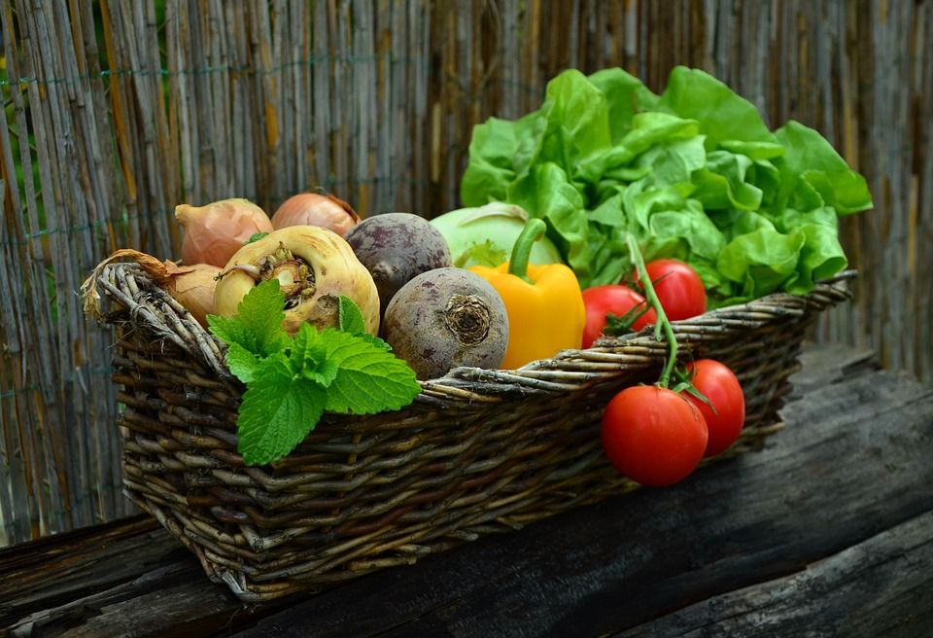
Enjoy seasonal specialties
As a Green Key certified establishment, we make special efforts to preserve the environment. We make food in an environmentally friendly way using organic, seasonal and/or local products. We want to make it easy for you to care for the environment – also when you eat – while giving you good, intriguing taste experiences.

