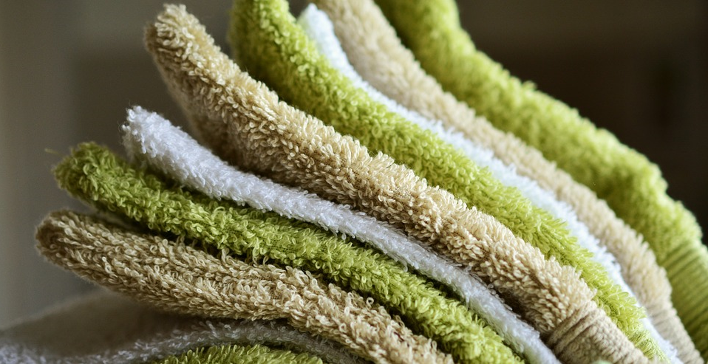

We choose environmentally friendly solutions
As a Green Key establishment, we make special efforts to preserve the environment. We use environmentally labelled cleaning agents, equipment and work methods, so that less chemicals and water are used.
We want to make it easy for you to make the right environmental choice without diminishing your comfort.

