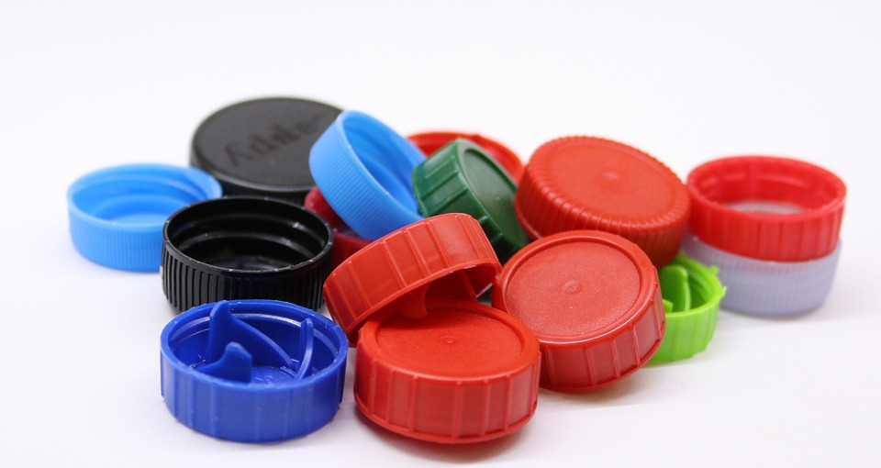

We sort waste
As a Green Key certified establishment, we make special efforts to preserve the environment. We sort waste in XXX, so that it can be recycled and is of less harm to the environment.
We want to make it easy for you to sort your waste without diminishing your comfort.

